**inSight 2017**

**Department : ECE department**

**Problem Title : Resume (online profile) builder and achievement tracker.**

**Problem Code : PS06**

**Problem Description :**

The students attend technical events like seminars, paper presentations, hackathons and many more. The faculties go to different colleges as guest lecturers, also to seminars and other events. In order to track these achievements of the faculty and students an application needs to be designed which would benefit the students and faculties by helping them build their resume(an online profile) and help the admin to keep track of the achievements. The application should provide students the interface to create their resume and store their inputs or responses in the form of a database so that it becomes a record for the department. This would enable the departments to track achievements of their students and faculties efficiently. This should also have provisions to edit their profile whenever they which to update their profile or resume. The application should be able to generate a report of these achievements whenever required.

**Proposed solution:**

*We will build an web based app which will have access to the student database. The privilege of an user will be based on their User Name (i.e admin/root can modify , add, remove, rectify data), whereas students and faculties can only add achievements and “request” for modification ,if need be.  
The admin will have the option to add new tables (i.e manipulate the data base) for eg., when a new session starts etc*

*Students and faculties will have the option to only add their achievements, through the web app (after login) .They will also have the ability to correct errors if any, by requesting the admin.*

*\*[Failsafe]=A provision to make the student , faculties produce their certificates etc to the admin, and hence prevent false entries can also be added .*

*The option to download the resume as pdf(or doc) will also added. This will be available to the faculty/student after the login.*

*The option to generate reports will be with the admin.*

**Technology Stack :**

*HTML/CSS/JavaScript: We will use these languages to create the webpage, describe the visual components, define actions in the webpage*

*SQL- SQL will be used to create the database.*

*PHP- PHP will be used to access and manipulate the database through the web app.*

*(The access will depend upon the user id).Also by combing PHP and SQL, we can have the option to “print/save to file” option for resume and report generation.*

**Use Case:**

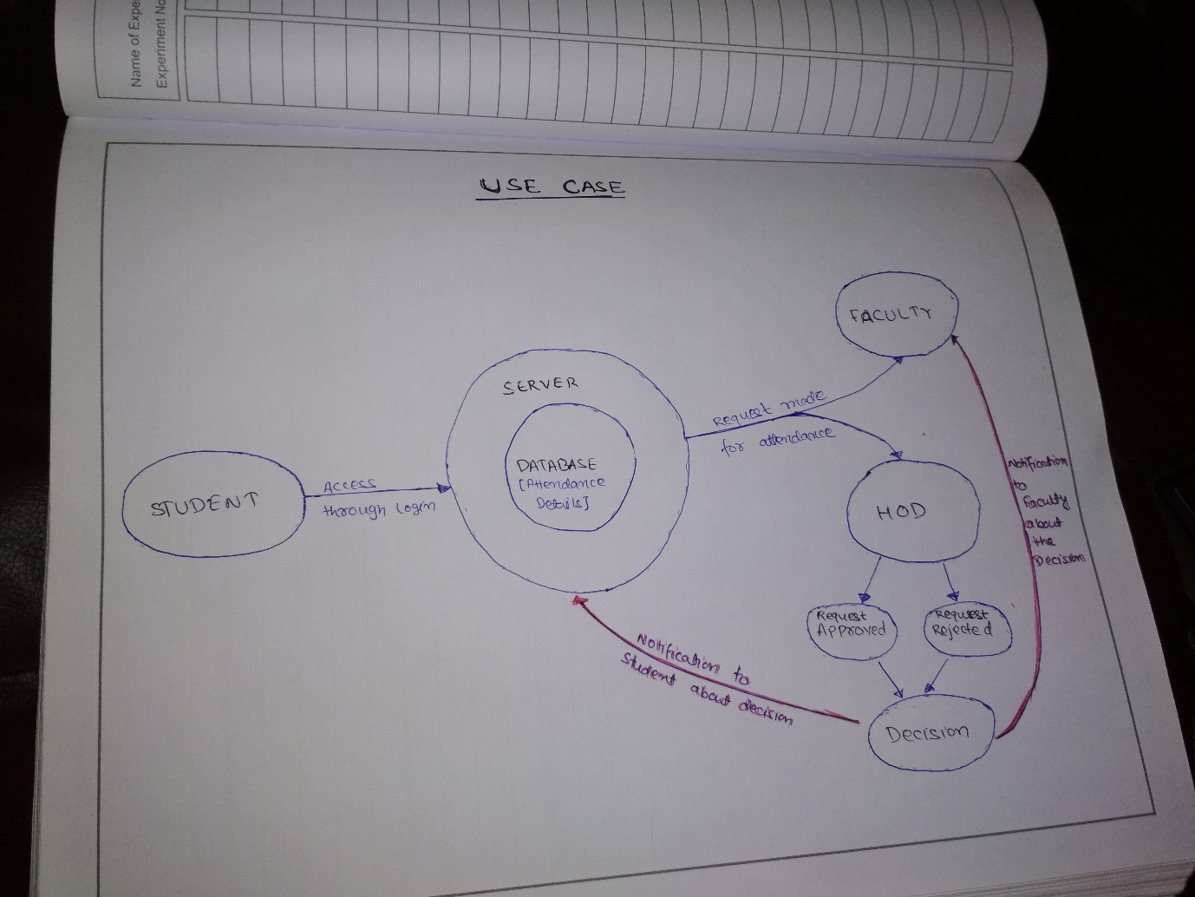

**Team Members details:**

|  |  |  |  |  |
| --- | --- | --- | --- | --- |
| **Role** | **Name** | **USN** | **Email id** | **Phone no.** |
| Team Leader | Ashish Kumar | 1SI15EC017 | [kumarashishtintin@gmail.com](mailto:kumarashishtintin@gmail.com) | 7204614977 |
| Team Member 1 | Farhan Ahmad | 1SI15EC031 | [tell2farhan@gmail.com](mailto:tell2farhan@gmail.com) | 8553052831 |